Program 1

Aim:
Implement Stack using linked list

Program code

#include<stdio.h>
#include<stdlib.h>
struct node
{
int data;
struct node *link;
}
*top=NULL;

int isEmpty()
{
if(top==NULL)
return 1;
else
return 0;
}
void push(int data)
{
struct node *newNode =(struct node*) malloc(sizeof( struct node));
if(newNode==NULL)
{
printf("Stack is overflow");

}
else
{
newNode->data=data;
newNode->link=NULL;
newNode->link=top;
top=newNode;
}
}

int pop()
{
struct node *temp;
int val;
if(isEmpty())
{
printf("Stack underflow\n");

}
else
{
temp=top;
val=temp->data;
top=temp->link;
free(temp);
temp=NULL;
printf("Deleted element is : %d",val);
}
}

int peek()
{
if(isEmpty())
{
printf("Stack underflow");
exit(1);
}
return top->data;
}

void search(int value)
{
struct node *temp;
temp=top;
int found;

if(isEmpty())
{
printf("Stack underflow");

}
else
{

while(temp)
{
if(temp->data==value)
{
found=1;
break;
}
temp=temp->link;
}
if(found==1)
{
printf("The element is inside stack\n");
}
else
{
printf("The element is not inside stack");

}

}

}

void print()
{
struct node *temp;
temp=top;
if(isEmpty())
{
printf("Stack underflow");
exit(1);
}

printf("The stack elements are:\n");
while(temp)
{
printf("%d\n",temp->data);
temp=temp->link;

}

}

int main()
{
int choice,data,value;
while(1)
{
printf("\n1.Push\n");
printf("2.Pop\n");
printf("3.Print the top element\n");
printf("4.Print all the elements of stack\n");
printf("5.Search\n");
printf("6.Quit\n");
printf("please enter your choice");
scanf("%d",&choice);
switch(choice)

{
case 1:
printf("enter the element to be pushed");
scanf("%d",&data);
push(data);
break;
case 2:
pop();

break;
case 3:
printf("The top most element of the stack is %d\n",peek());
break;
case 4:
print();
break;
case 5:
printf("Enter value to be search");
scanf("%d",&value);
search(value);
break;
case 6:
exit(1);
default:
printf("Wrong choice\n");
}
}
return 0;
}

Ouput:

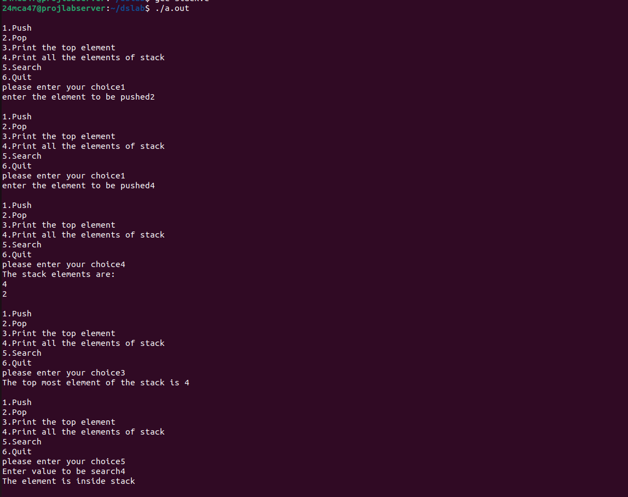

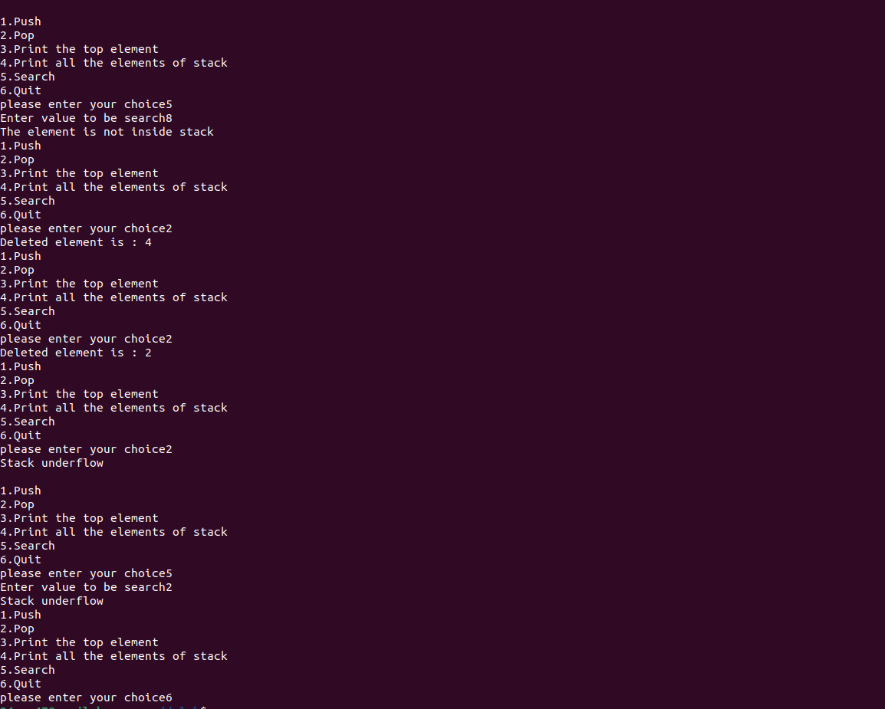

PROGRAM-2

Aim:
Implement singly linked list

program code:

#include<stdio.h>
#include<stdlib.h>

struct node
{
int data;
struct node *next;
};
struct node *head=NULL;

struct node *createNode(int data)
{
struct node *newNode=(struct node*)malloc(sizeof(struct node));
newNode->data=data;
newNode->next=NULL;
return newNode;
}

void insertAtBeginning(int data)
{
struct node *newNode=createNode(data);
newNode->next=head;
head=newNode;
}

void insertAtEnd(int data)
{
struct node *newNode=createNode(data);
if(head==NULL)
{
head=newNode;
return;
}
struct node *temp=head;
while(temp->next!=NULL)
{
temp=temp->next;
}
temp->next=newNode;
}

void insertAtAnyPosition(int data,int position)
{
if(position<1)
{
printf("Enter position greater than 1\n");
return;
}

if(position==1)
{
insertAtBeginning(data);
return;
}
struct node *newNode=createNode(data);
struct node *temp=head;
for(int i=1;i<position-1 && temp!=NULL;i++)
{
temp=temp->next;
}
if(temp==NULL)
{
printf("Position out of bounds\n");
free(newNode);

}
else
{
newNode->next=temp->next;
temp->next=newNode;
}
}

void deleteAtBeginning()
{
if(head==NULL)
{
printf("List is empty\n");
return;
}
struct node *temp=head;
head=head->next;
free(temp);
}

void deleteAtEnd()
{
if(head==NULL)
{
printf("List is empty\n");
return;
}
struct node *temp=head;
struct node *prev=NULL;
if(head->next==NULL)
{
free(temp);
head=NULL;
}
else
{
while(temp->next!=NULL)
{
prev=temp;
temp=temp->next;
}
prev->next=NULL;
free(temp);

}
}

void deleteAtAnyPosition(int position)
{
if(head==NULL)
{
printf("List is empty\n");
return;
}
if(position<1)
{
printf("Position must be greater than zero\n");
return;
}
if(position==1)
{
deleteAtBeginning();
return;
}
struct node *temp=head;
struct node *prev=NULL;
for(int i=1;i<position && temp!=NULL;i++)
{
prev=temp;
temp=temp->next;
}
if(temp==NULL)
{
printf("Position out of bound");
}
else
{
prev->next=temp->next;
free(temp);
}

}

void display()
{
struct node *temp=head;
if(temp==NULL)
{
printf("List is Empty\n");
return;
}
while(temp!=NULL)
{
printf("%d\t",temp->data);
temp=temp->next;
}
}

void search(int value)
{
struct node *temp=head;
int found,position=1;
if(temp==NULL)
{
printf("List is Empty\n");
return;
}
while(temp!=NULL)
{
if(temp->data==value)
{
found=1;
break;
}
temp=temp->next;
position++;
}
if(found==1)
{
printf("Data found at %d\n",position);
}
else
{
printf("Value not found in list\n");
}
}

int main()
{
int choice,data,value,position;
do
{
printf("\nSelect your choice\n");
printf("1.Insert At Beginning List\n");
printf("2.Insert At End of List\n");
printf("3.Insert At Any Position of List\n");
printf("4.Delete At Beginning of List\n");
printf("5.Delete At End of List\n");
printf("6.Delete At Any Position of List\n");
printf("7.Display List\n");
printf("8.Search an element in list\n");
printf("9.Exit\n");
printf("Enter Your choice\n");
scanf("%d",&choice);
switch(choice)
{
case 1:
printf("Enter data to be inserted\n");
scanf("%d",&data);
insertAtBeginning(data);
break;

case 2:
printf("Enter data to be inserted\n");
scanf("%d",&data);
insertAtEnd(data);
break;

case 3:
printf("Enter data to be inserted\n");
scanf("%d",&data);
printf("Enter Position to be insert data\n");
scanf("%d",&position);
insertAtAnyPosition(data,position);
break;

case 4:
deleteAtBeginning();
break;

case 5:
deleteAtEnd();
break;

case 6:
printf("Enter Position to be delete data\n");
scanf("%d",&position);
deleteAtAnyPosition(position);
break;

case 7:
display();
break;

case 8:
printf("Enter value to be searched\n");
scanf("%d",&value);
search(value);
break;

case 9:
printf("Exiting");
exit(0);
break;

default:
printf("Wrong choice");
break;
}
}

while(choice!=9);
return 0;
}

Output:

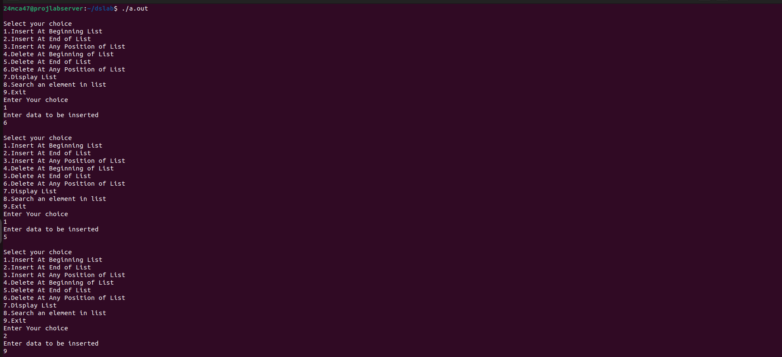

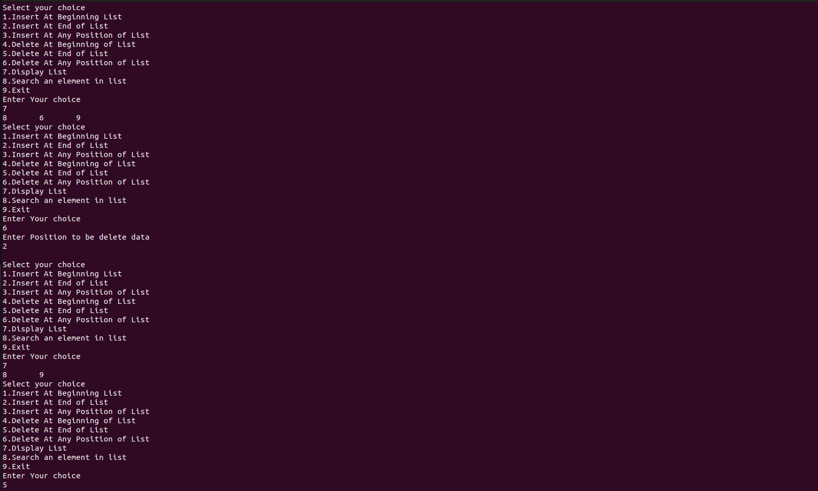
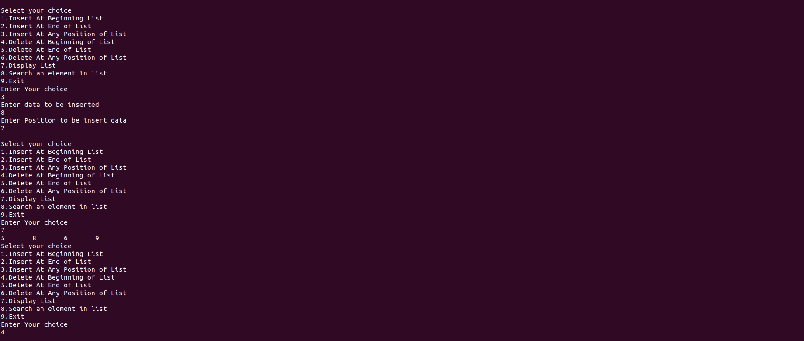
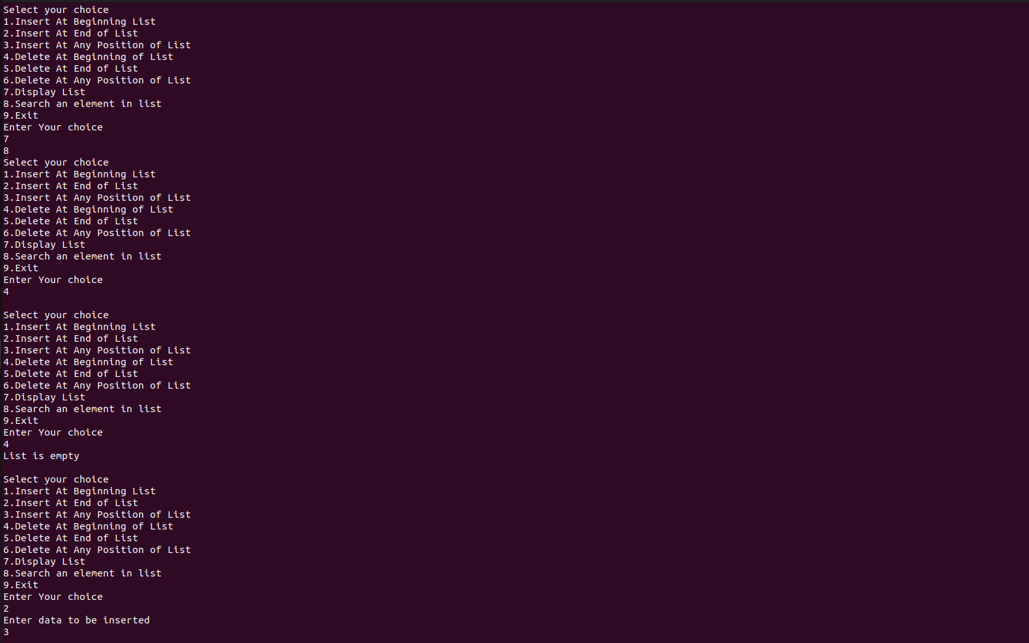

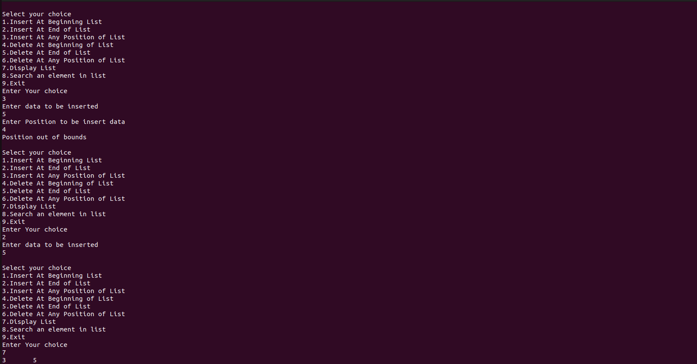

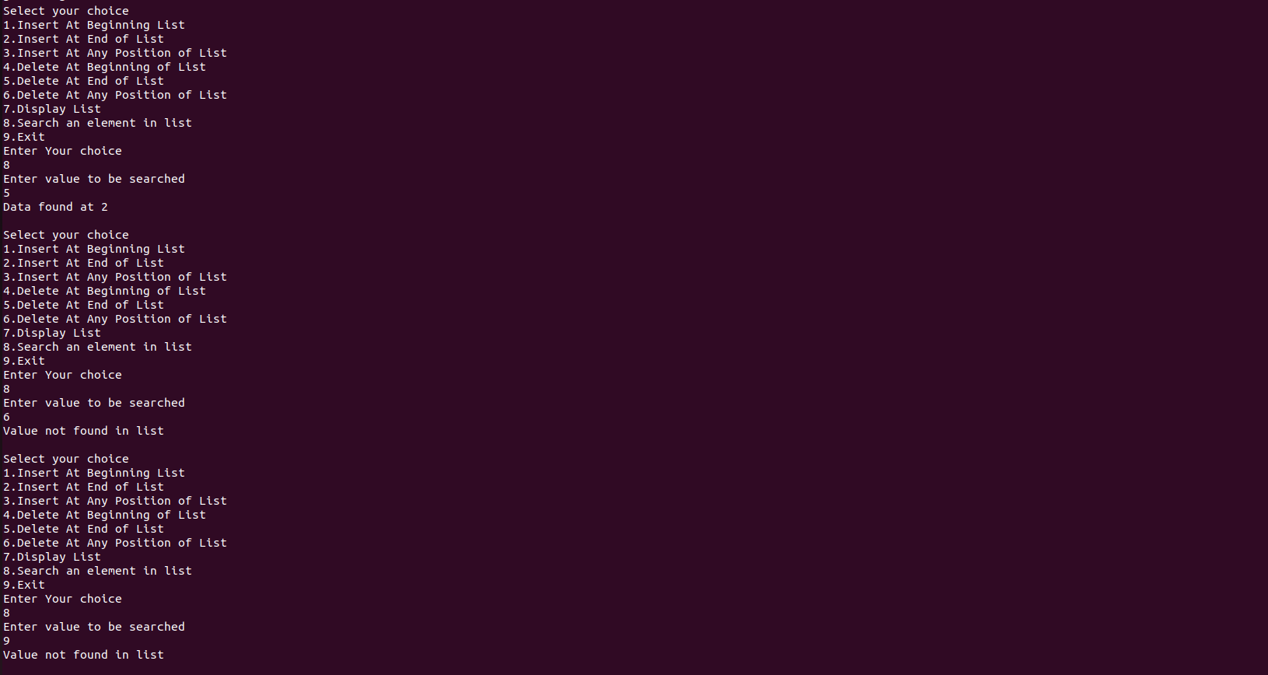

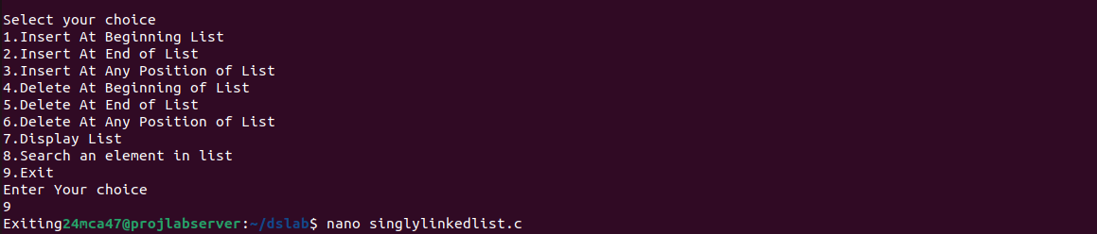

Program 3

Aim:
Implement Doubly linked list

Program code

#include<stdio.h>
#include<stdlib.h>
struct Node{
struct Node* prev;
int data;
struct Node* next;
};
struct Node* head=NULL;
struct Node* createNode(int data)
{
struct Node* newNode=(struct Node*)malloc(sizeof(struct Node));
newNode->prev=NULL;
newNode->data=data;
newNode->next=NULL;
return newNode;
}

void insertAtBeginning(int data)
{
struct Node *newNode=createNode(data);
newNode->prev=NULL;
newNode->next=head;
head=newNode;
}

void insertAtEnd(int data)
{
struct Node *newNode=createNode(data);
if(head==NULL)
{
head=newNode;
return;
}
struct Node *temp=head;
while(temp->next!=NULL)
{
temp=temp->next;
}
temp->next=newNode;
newNode->prev=temp;
newNode->next=NULL;
}

void insertAtAnyPosition(int data,int position)
{
if(position<1)
{
printf("Enter position greater than 1\n");
return;
}

if(position==1)
{
insertAtBeginning(data);
return;
}
struct Node *newNode=createNode(data);
struct Node *temp=head;
for(int i=1;i<position-1 && temp!=NULL;i++)
{
temp=temp->next;
}
if(temp==NULL)
{
printf("Position out of bounds\n");
free(newNode);

}
else
{
newNode->next=temp->next;
temp->next->prev=newNode;
temp->next=newNode;
newNode->prev=temp;
}

}
void deleteAtBeginning()
{
if(head==NULL)
{
printf("List is empty\n");
return;
}
struct Node *temp=head;
head=temp->next;
if(head!=NULL)
{
head->prev=NULL;
}
free(temp);
printf("Item Deleted from List\n");
}

void deleteAtEnd()
{
if(head==NULL)
{
printf("List is empty\n");
return;
}
struct Node *temp=head;
struct Node *loc=NULL;
if(head->next==NULL)
{
free(temp);
head=NULL;
}
else
{
while(temp->next!=NULL)
{
loc=temp;
void deleteAtAnyposition(int position)
{
if(head==NULL)
{
printf("List is empty\n");
return;
}
if(position<1)
{
printf("Position must be greater than zero\n");
return;
}
if(position==1)
{
deleteAtBeginning();
return;
}
struct Node *temp=head;
struct Node *loc=NULL;
for(int i=1;i<position && temp!=NULL;i++)
{
loc=temp;
temp=temp->next;
}
if(temp==NULL)
{
printf("Position out of bound");
}
else
{
loc->next=temp->next;
loc->prev=temp->prev;
free(temp);
printf("Item Deleted from List\n");
}

} temp=temp->next;
}
loc->next=NULL;
free(temp);
printf("Item Deleted from List\n");

}

}

void display()
{
struct Node *temp=head;
if(temp==NULL)
{
printf("List is Empty\n");
return;
}
while(temp!=NULL)
{
printf("%d\t",temp->data);
temp=temp->next;
}
}

void search(int value)
{
struct Node *temp=head;
int found,position=1;
if(temp==NULL)
{
printf("List is Empty\n");
return;
}
while(temp!=NULL)
{
if(temp->data==value)
{
found=1;
break;
}
temp=temp->next;
position++;
}
if(found==1)
{
printf("Data found at %d\n",position);
}
else
{
printf("Value not found in list\n");
}
}
int main()
{
int data,position,choice,value;
do
{
printf("\nDoubly Linked List Operations:\n");
printf("Select your choice\n");
printf("1.Insert At Beginning\n");
printf("2.Insert At End\n");
printf("3.Insert At Any Position\n");
printf("4.Delete At Beginning\n");
printf("5.Delete At End\n");
printf("6.Delete At Any Position\n");
printf("7.Display List\n");
printf("8.Search\n");
printf("9.Exit\n");
printf("Enter Your Choice:");
scanf("%d",&choice);
switch(choice)
{
case 1:
printf("Enter the data to be entered:\n");
scanf("%d",&data);
insertAtBeginning(data);
break;
case 2:
printf("Enter the data to be entered:\n");
scanf("%d",&data);
insertAtEnd(data);
break;
case 3:
printf("Enter the data to be entered:\n");
scanf("%d",&data);
printf("Enter the position to be entered:\n");
scanf("%d",&position);

insertAtAnyPosition(data,position);
break;
case 4:
deleteAtBeginning();
break;
case 5:
deleteAtEnd();
break;
case 6:
printf("Enter position to be deleted\n");
scanf("%d",&position);
deleteAtAnyposition(position);
case 7:
display();
break;
case 8:
printf("Enter value to be searched\n");
scanf("%d",&value);
search(value);
break;
case 9:
printf("Exiting");
exit(0);
break;
default:
printf("Enter proper choice\n");
break;

}
}
while(choice!=9);
return 0;

}

Output:

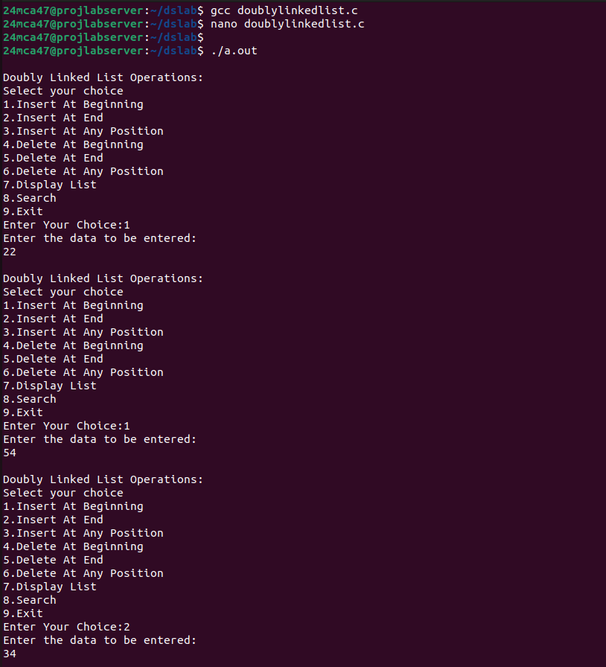

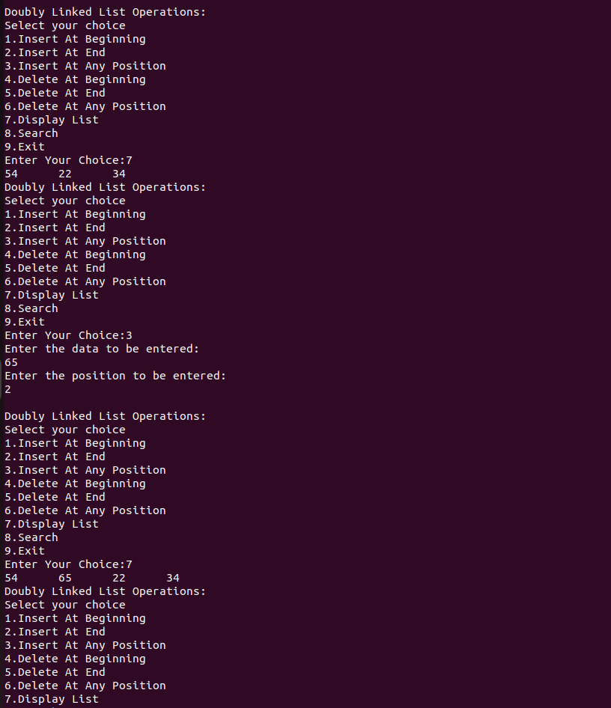

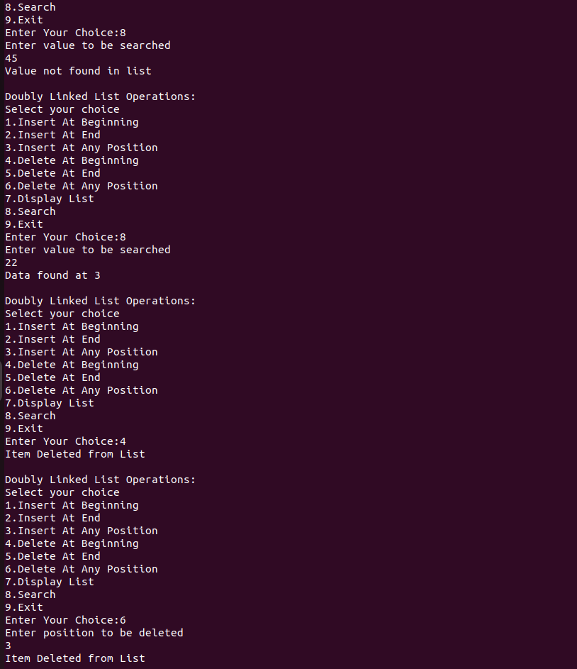

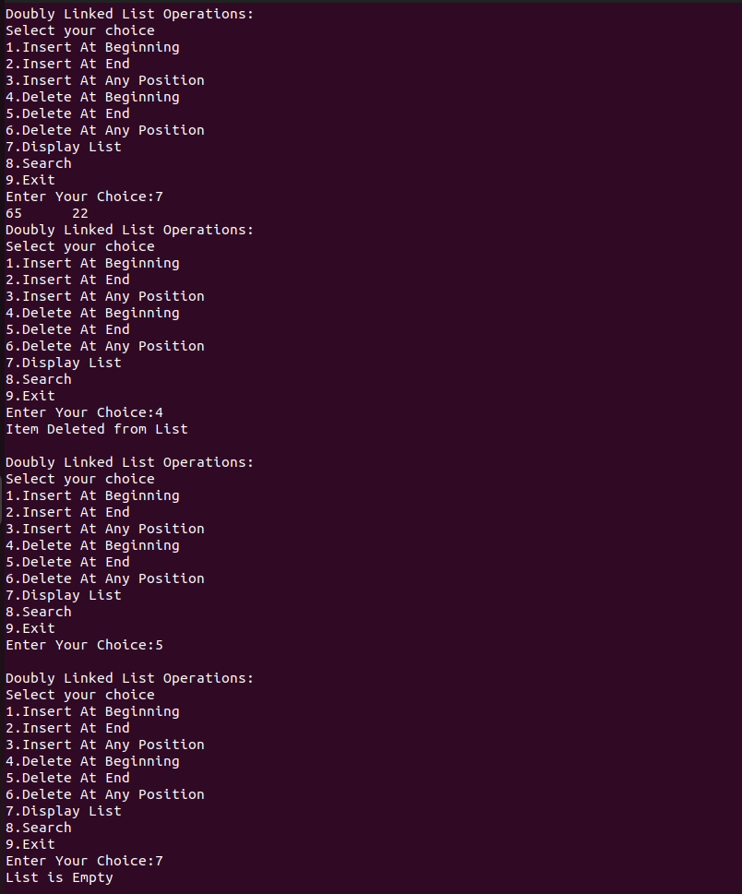

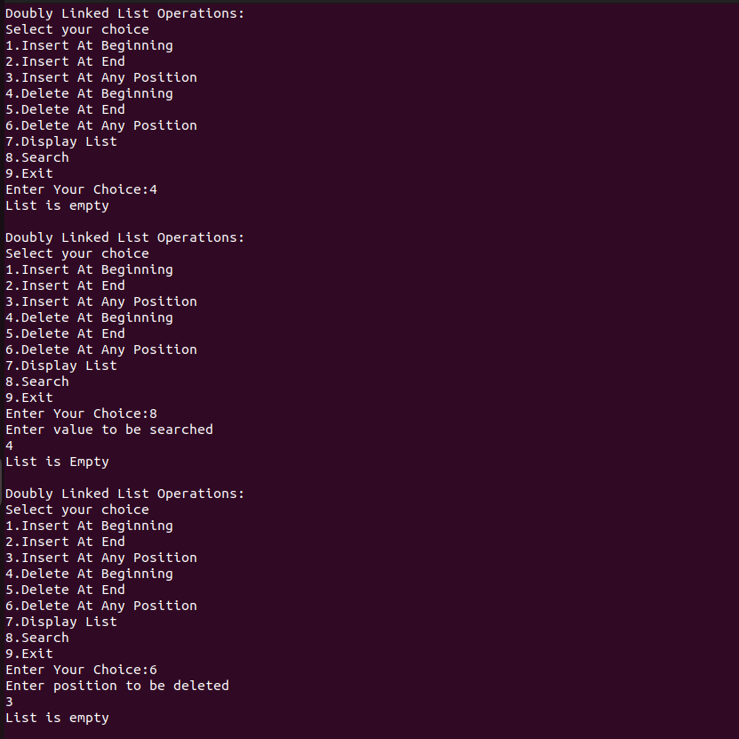

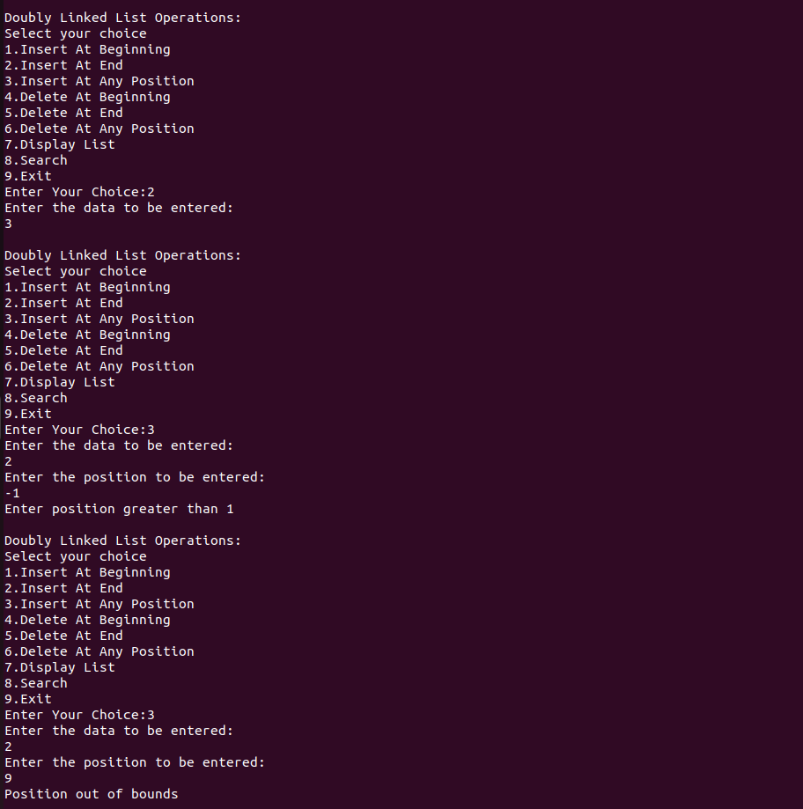



Program 4

Aim:
Implement Binary Search Tree

Program code:

#include<stdio.h>
#include<stdlib.h>
struct node{
int data;
struct node *left;
struct node *right;

};

struct node* createnode(int data)
{
struct node* newNode=(struct node*)malloc(sizeof(struct node));
newNode->data=data;
newNode->left=NULL;
newNode->right=NULL;
return newNode;
}

struct node* insert(struct node* root,int data)
{
if(root==NULL)
{
root=createnode(data);

}
else if(data<root->data)
{
root->left=insert(root->left,data);
}
else if(data>root->data)
{
root->right=insert(root->right,data);
}
return root;

}

struct node* findMin(struct node *root)
{
while(root && root->left!=NULL)
{
root=root->left;
}
return root;
}
struct node* deleteNode(struct node* root,int data)
{
if(root==NULL)
{
printf("The value to be deleted is not present inside tree\n");
return root;
}
if(data<root->data)
{
root->left=deleteNode(root->left,data);

}
else if(data>root->data)
{
root->right=deleteNode(root->right,data);
}
else{
if(root->left==NULL)
{
struct node* temp=root->right;
free(root);
return temp;
}
else if(root->right==NULL)
{
struct node* temp=root->left;
free(root);
return temp;
}
struct node *temp=findMin(root->right);
root->data=temp->data;
root->right=deleteNode(root->right,temp->data);
}
return root;
}

struct node* search(struct node* root,int data)
{
if(root==NULL || root->data==data)
{
return root;
}
if(data<root->data)
{
return search(root->left,data);
}
else{
return search(root->right,data);
}
}

void preorder(struct node *root)
{
if(root!=NULL)
{
printf("%d->",root->data);
preorder(root->left);
preorder(root->right);
}
}

void inorder(struct node *root)
{
if(root!=NULL)
{
inorder(root->left);
printf("%d->",root->data);
inorder(root->right);
}
}

void postorder(struct node *root)
{
if(root!=NULL)
{

postorder(root->left);
postorder(root->right);
printf("%d->",root->data);
}
}

int main()
{
struct node* root=NULL;
int choice,value;
struct node* foundNode;
while(1)
{
printf("\nBinary Tree Operations:\n");
printf("Select your choice:\n");
printf("1.Insert \n");
printf("2.Delete\n");
printf("3.Search Tree\n");
printf("4.Preorder Traversal\n");
printf("5.Inorder Traversal\n");
printf("6.Postorder Traversal\n");
printf("7.Exit\n");
printf("Enter Your choice:\n");
scanf("%d",&choice);
switch(choice)
{
case 1:
printf("Enter Data to be entered\n");
scanf("%d",&value);
root=insert(root,value);
break;
case 2:
if(root==NULL)
{
printf("Tree is empty");
}
else
{
printf("Enter Data to be Deleted\n");
scanf("%d",&value);
root=deleteNode(root,value);
}
break;

case 3:
if(root==NULL)
{
printf("Tree is empty");
}
else
{

printf("Enter value to be searched\n");
scanf("%d",&value);
foundNode=search(root,value);
if(foundNode!=NULL)
{
printf("Value %d found in the tree.\n",value);
}
else
{
printf("Value %d not found in the tree.\n",value);

}
}
break;
case 4:
if(root==NULL)
{
printf("Tree is empty");
}
else
{
printf("Preorder Traversal:");
preorder(root);
printf("\n");
}
break;case 5:
if(root==NULL)
{
printf("Tree is empty");
}
else
{
printf("Inorder Traversal:");
inorder(root);
printf("\n");
}
break;

case 6:
if(root==NULL)
{
printf("Tree is empty");
}
else
{
printf("PostOrder Traversal:");
postorder(root);
printf("\n");
}
break;

case 7:
printf("Exiting");
exit(0);
break;
default:
printf("Invalid choice Try Again..\n");
break;

}
}

return 0;
}

Output:

